EPISD AND CAPT. J.L. CHAPIN HIGH SCHOOL GOALS:

**GOAL 1:** EPISD/Chapin will ensure our community has a successful, culturally responsive school in every neighborhood that successfully engages and prepares all students for graduation and post-secondary success.

**GOAL 2:** EPISD/Chapin will ensure our students, employees, and community are provided a safe, secure, environmentally conscious, and vibrant learning environment.

**GOAL 3:** EPISD/Chapin will demonstrate fiscal and ethical responsibility as well as a deep commitment to service orientation in all district operations.

**GOAL 4:** EPISD/Chapin will recruit, employ, develop and retain a highly effective and qualified staff that successfully engages all students for success.

**GOAL 5:** EPISD/Chapin will maintain positive and productive partnerships with parents, our community, Fort Bliss and EPISD to facilitate the success of all students.



AT HOME

As parents/families, it is important to me that my child reach his/her fullest academic and social potential. Therefore, I will encourage him/her by doing the best of their ability and we will support our children’s learning in by:

_____See that my child is punctual and attends school regularly.

_____Support the school in its efforts to maintain proper discipline.

_____Establish a time for homework and review it regularly.

_____Provide a quiet, well-lighted place for study.

_____Encourage my child’s efforts and be available for questions.

_____Stay aware of what my child’s needs and learning.

_____Staying informed about my child’s education by promptly reading all notices sent to me from the school, or from the district that I receive by my child or by mail and responding, as appropriate.

_____Promote the pillars of trustworthiness, respect, responsibility, fairness, caring, and citizenship in my child.

Parent Signature:___________________________Date:________

IN THE CLASSROOM

As Chapin Teachers, we will and promise to:

_____Show care and equality to all students

_____So set high expectations for students, staff and myself

_____Communicate regularly and work with students and families to support learning

_____ Provide a safe and caring learning environment where your child will be responsible for his or her own behavior and learning.

_____Respect the cultural differences of students and their families

_____ Use strategies and activities that take into account individual strengths in children.

_____Support college readiness in all classrooms on a weekly basis

_____ Provide frequent and ongoing communication to you about your child's progress.

_____Monitor, adapt, and provide feedback about instruction

_____Implement and follow PBIS Principles in my classroom, and throughout the school

Teacher Signature: ____________________________

STUDENTS

It is important that I work to the best of my ability, therefore as a Chapin Husky I will:

_____ Wear the student I.D. issued to me at the beginning of the school year at all times during the school day.

_____Attend school daily, on time, and be prepared to participate in class.

_____ Adhere to PBIS, come to school each day with pens, pencils, paper and other necessary tools for learning.

_____Attend tutoring, as needed and observe regular study hours, and complete and return homework assignments.

____Ensure my laptop is charged and ready for use in class, every day.

_____ Follow the Chapin High School Code of Conduct as well as the rules of my classroom teacher. Try my best to be trustworthy, respectful, responsible, fair, caring, and to be a good citizen.

_____ Take the SAT/PSAT as offered by the school

_____Work towards my full potential in all areas of academics, sports, and community.

Student Signature: ____________________________

STUDENTS, TEACHERS, PARENTS – WORKING TOGETHER FOR SUCCESS!

Capt. J.L. Chapin High School, parents and families, of students participating in activities, services, and programs funded by Title I, Part A of the Elementary and Secondary Education Act (ESEA), agree this compact outlines how parents, families, school staff, and students will share the responsibility for improved student academic achievement and the means by which the school parents and families will build and develop a partnership to help children achieve the State’s high standards.

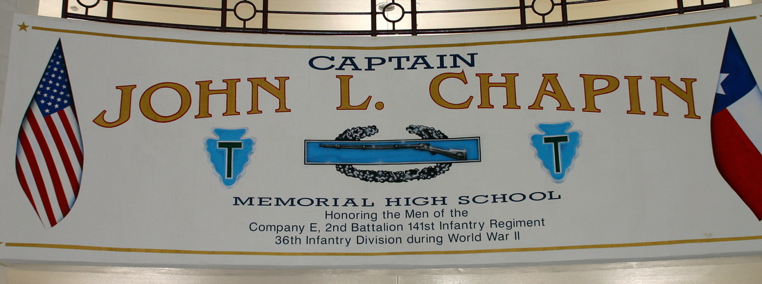

WHAT IS A SCHOOL-PARENT COMPACT?

A school compact is a written agreement between a school, parents, families, and students. The compact gives strategies to help support students’ success in school. The compact explains what families and schools can do to make a connection for the student between the two “worlds” they live in, home and school. Parents, families, students, and the schoolwork together to create a group of ideas that can assist students with realizing their potential. This becomes the compact that is signed as an agreement by all those involved in the child’s education.

HOW WE WILL COMMUNICATE?

* Title 1 Parent Meeting to discuss school policies.
* Monthly Campus Improvement Team meetings.
* Parent Teacher Conferences to be held mid- semester, in both the Fall and Spring Semesters.
* Send newsletters home to communicate all that is happening in the school.
* Various parent meetings through-out the year.

Every new school year we hold informative parent meetings that focus on helping our students be successful at Chapin. We also invite all parents and families to stay involved with their student's education with various activities and sports boosters. Other important dates are:

9th-12th Grades: College Nights/Military Academy Nights

9th – 11th Grades: PSAT – January 11, 2023

11th and 12th Grades: FAFSA Night – Application process and assistance

12th Grades: SAT – Wed. September 21, 2022 8:00am

End of Course (EOC) exam dates by subject:

* + **English 1 – December 6, 2022**
  + **English 2 – December 8, 2022**
  + **Algebra 1 – December 7, 2022**
  + **US History – December 7, 2022**
  + **Biology– December 7, 2022**
  + **Make-up – December 9, 2022**
  + **Online testing window**

**December 6-16, 2022**

*subject to change based on District AP Testing

Principal Capt. J.L. Chapin HS

It is important to me that my students reach their fullest academic and social potential. Therefore, I will encourage your child by doing the following:

1. Provide high-quality curriculum in a safe and caring learning environment where your child will be responsible for his or her own behavior and learning. Use strategies and activities that take into account individual strengths in children. Utilize the best practices in education to meet the State’s student academic achievement standards.

2. Provide frequent and ongoing communication to you about your child's progress.

3. Provide accurate counseling services to students for correct completion of House Bill 5 pathway requirement and successful class placement for Texas graduation requirements.

4. Provide the resources needed to bridge the transition between middle and high school.

5. Maintain open communication for the successful implementation of needed educational resources for the successful completion of EOC graduation requirements.

6. Maintain open communication for the successful implementation of needed educational resources for the successful completion of EOC graduation requirements.

7. Provide parents and families reasonable access to staff. Specifically, staff will be available for consultation with parents and families as follows: Individual/team parent teacher conferences may be requested by calling our main number (915) 236-4400. Emailing teachers/staff directly thru Parent portal. If there has not been a response within 72hrs, parents and families are welcome to contact the Parent Involvement Liaison- Bonnie Logsdon (915) 236-4400 ext 64581 [brlogsd6@episd.org](mailto:brlogsd6@episd.org)

____________________________________

Chapin HS Principal



CAPT. J.L. CHAPIN HIGH SCHOOL

SCHOOL-PARENT COMPACT

**Our Mission Statement:**

**Embodying the legacy of Captain John L Chapin and the men of Company E**

**Vision:**

The Chapin community embraces the diversity of all students and prepares them for a globally competitive future as responsible, life-long learners who are empowered to be successful contributors to society. Collaboration, safety, and trust empower our school community to allow all students to achieve their full potential. Diversity is a positive and powerful tool to build a supportive and involved educational community. Our focus is to create a climate that provides all students the opportunity to engage in their education.

**7000 Dyer St.**

**El Paso, Texas 79904**

**(Main) 915-236-4400**

**(Fax) 915-565-9716**

**http://chapin.episd.org/**

CAPT. J.L. CHAPIN HIGH SCHOOL

2022-2023